***HOMEMADE SOUP***

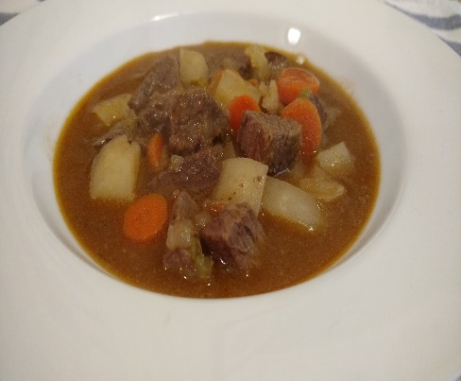

[This Photo](http://sowhatareyoumakingfordinner.blogspot.com/2016/04/the-best-beef-stew-and-amazing.html) by Unknown Author is licensed under [CC BY-NC](https://creativecommons.org/licenses/by-nc/3.0/)

2 LBS GROUND HAMBERGER

Place meat in a large cooking kettle

Cover with water and let cook while preparing the other ingredients.

Add 2/3 cup uncooked rice to the meat mixture.

1 cup celery chopped, ½ cup onion, 3 garlic cloves (chopped)

1 cup carrots (frozen), 1 cup peas (frozen)

1 cup corn, 1 cup green beans.

Add the vegetables to the meat and let simmer until cooked through

Then add one large can of diced tomatoes, and top with chopped cabbage.

Add salt and pepper to taste.

Add enough water to the kettle to keep the soup moist and consistency to

Your approval.